# Home Screen

1. Select an item from the header navbar to make use of a module.

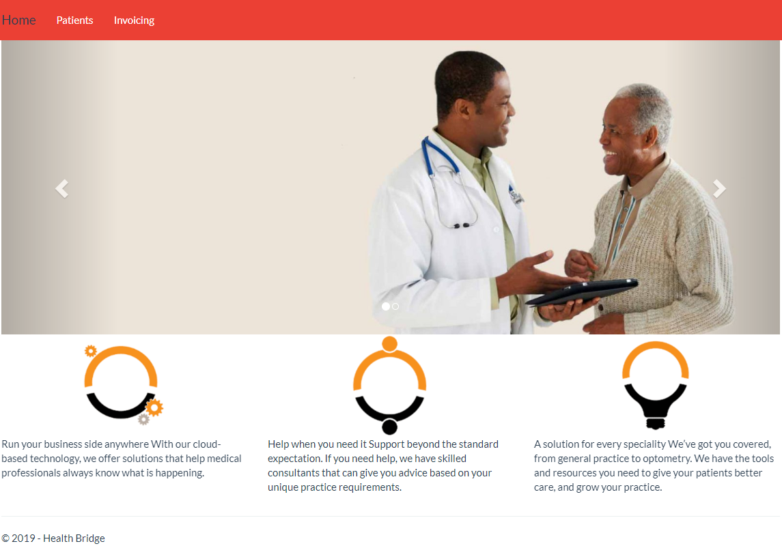

# Patient Module

1. To add a new patient, click the “Add New Patient” button.
2. A list of all patients will be available once the page has loaded.
3. The patient dashboard screen table has sorting and paging features.
4. To edit a patient, click the edit button which would redirect you to a patient capture form,
5. To delete a patient, click the delete button.

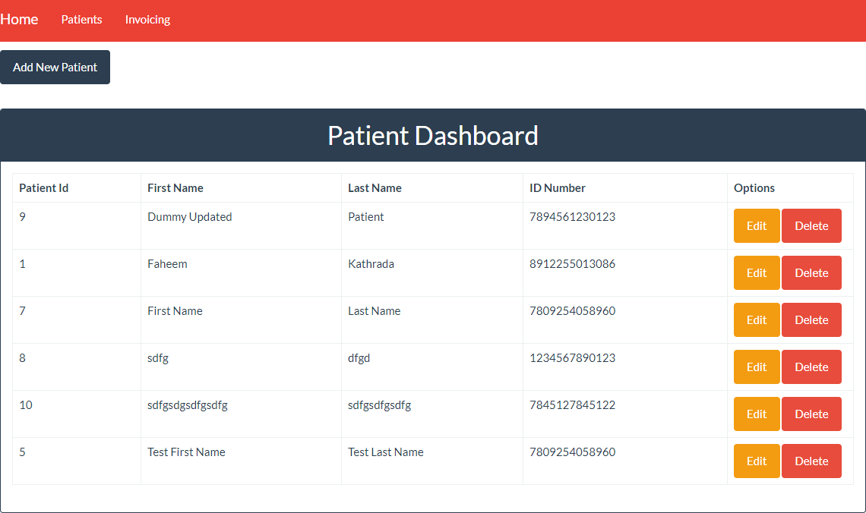

# Patient Capture Form

1. This form is used to add or edit a patient.
2. Ensure that all fields have been captured to avoid validation errors.
3. Once details have been captured click “Save” to add the new patient or to update an existing patient.

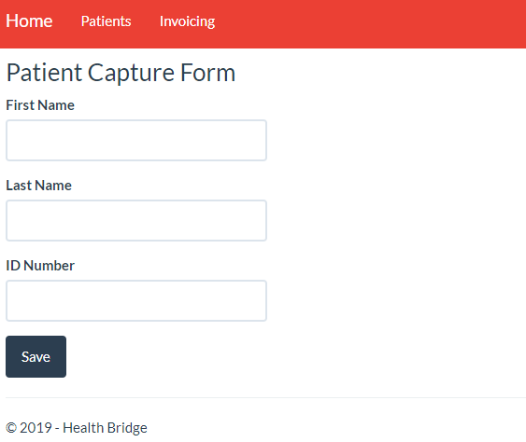

# Invoice Dashboard

1. To Add a new invoice, use the “Generate Invoice” button.
2. A list of invoices will be available once the page has loaded.
3. Use the “Edit” button to edit an invoice.
4. Use the “Delete” button to delete an invoice.

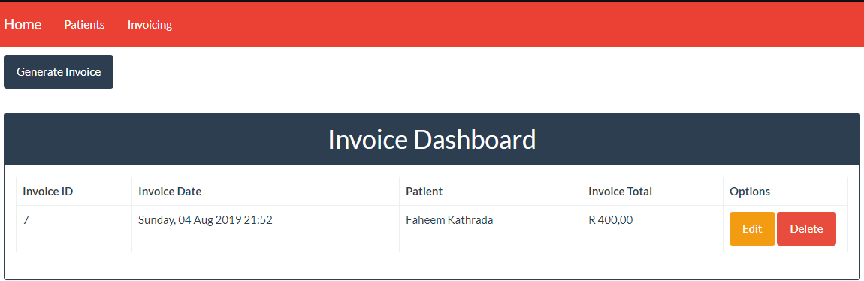

# Invoice Line Items

1. A patient has to be selected in order to save a new invoice.
2. Enter QTY, Code, Description and a Total in order to add a Line Item to the invoice HTML table.
3. The total at the bottom of the page is automatically calculated as a user adds/removes/updates any line items.
4. Use the edit/delete buttons to edit or delete line items.

